Emp 111594594

Date 31/05/2025

Pentakota Sai Kumar

Task 1

**REGULAR EXPRESIONS REGEx ON LINUX**

. It is called a wildcard character it matches any one character other

than the new line

**^** it matches the start of the string

**$** it matches the end of the string

**\***  it matches up to zero or more ocuurrences

**\** it is used for escape following character

**()** it is used to match or search for a set of regular expressions

**?**  it matches exactly one character in the string or stream

Task 2

**Features of Linux**

1. Open source
2. Portability
3. Security
4. Stability and reliability
5. Multiuser and multitasking
6. Flexibility and customization

**What is kernel ?**

Kernel is the fundamental core of an operating system it is the brain or heart of the os it is a computer program that has complete control over everything in the system.

**Bash -** Bourne again shell

Shell is a command line interpreter or a program that provides an interface between the user and operating systems kernel

**What do you think is the difference between LInux and Windows ?**

**Linux windows**

Open source developed by microsoft

Mostly free paid licence

Modifiable closed source

Highly customizable limited customization

More secure less secure

Uses bash uses command& prompt power shell

**What are the basic components of Linux? Describe each in detail with diagrams**

**Kernel:**

The heart of the Linux system, acting as an interface between the hardware and the rest of the software. It manages memory, processes, file systems, and networking.

**System Libraries:**

Provide reusable code that applications and system utilities use to interact with the kernel and perform various OS functions.

**System Utilities**:

These are programs designed for specific tasks, like managing files, processes, or system settings.

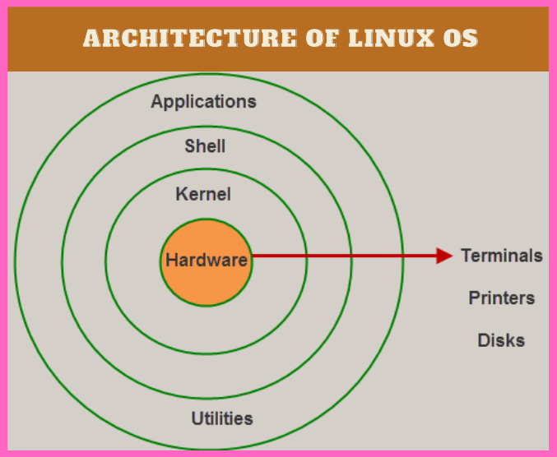

Is it legal to edit Kernal ? when do you think we have to in case?

Yes, it is legal to edit a Linux kernel because it is open-source and released under the GNU General Public License (GPL). The GPL allows for modification, redistribution, and even sale of the software, as long as the recipient can rebuild the software from source.

**What is LILO? Explain**

Linux Loader is an older boot loader used in Linux systems to load the operating system kernel. It was a widely used method for managing the boot process, particularly in the early days of Linux. LILO can be used to boot Linux or other operating systems from the same machine.

**What is shell? How many shells are there and what are they ? can you explain.**

"shell" is a program that serves as an interface between the user and the operating system's kernel. It takes user input, interprets it, and executes the corresponding commands or programs on the operating system, then displays the output.

There are two main types of shells:

**Command-line interface (CLI) shell**:

These shells are text-based and allow users to interact with the OS by typing commands. Examples include Bash, Zsh, and Fish.

**Graphical user interface (GUI) shell:**

These shells provide a visual interface for interacting with the OS, such as the Windows Explorer or macOS Finder.

**What is swap space?**

Swap space in Linux is an area on a hard drive or SSD that serves as virtual memory. It's used when the system runs out of physical RAM to temporarily store inactive data. This allows the system to continue running processes even when RAM is full, by moving data to the slower swap space and back as needed**.**

When RAM is full, the Linux kernel can move inactive or infrequently used data from RAM to the swap space on the hard drive.

This frees up RAM for currently active processes.

When the data in swap space is needed again, it's moved back from the swap space to RAM.

Swap space can be a dedicated partition or a swap file.

**What is Mount ? how do you mount and unmount file system in Linux?**

In Linux, "mount" refers to attaching a filesystem like a hard drive partition, a USB drive, or a network share to the directory structure, making its contents accessible. The mount command itself is used to perform this action, while umount is used to detach a filesystem.

Mounting a File System:

1. Create a Mount Point:

First, you need a directory where the filesystem will be mounted. This is a directory in your existing file system where you will access the mounted filesystem.

2. Use the mount Command:

The syntax is mount <device> <mount_point>, where <device> is the filesystem (e.g., /dev/sda1) and <mount_point> is the directory created in step 1.

3. Example:

To mount the first partition of the second hard drive (assuming it's /dev/sda1) to a directory called /mnt/new_drive, you'd run: mount /dev/sda1 /mnt/new_drive.

Unmounting a File System:

1. Use the umount Command:

The syntax is umount <mount_point>. You can also use <device> instead of <mount_point>, but using the mount point is generally preferred.

**What is chmod command ? how to use it?**

The "chmod" command modifies the read, write, and execute permissions of specified files and the search permissions of specified directories. who you are giving permissions to. Specified in the order: user, group, others. The permissions that can be given are : read, write or execute.

**What is the difference between Process and Thread?**

A process is a program in execution, while a thread is a unit of execution within a process. Processes are independent, with their own memory space, while threads within the same process share memory and resources. Threads are lighter than processes, meaning they require fewer resources and have faster context switching.

